1. **Define Artificial Intelligence. Summarize any five common benefits of Artificial Intelligence technology. List out any five real-time applications of AI.**

Artificial intelligence (AI) is the study of ideas that enable computers to be intelligent. The goals of the field of artificial intelligence are to make computers more useful and to understand the principles that make intelligence possible.

◦ Systems that think like humans ; Systems that think rationally

◦ Systems that act like humans ; Systems that act rationally

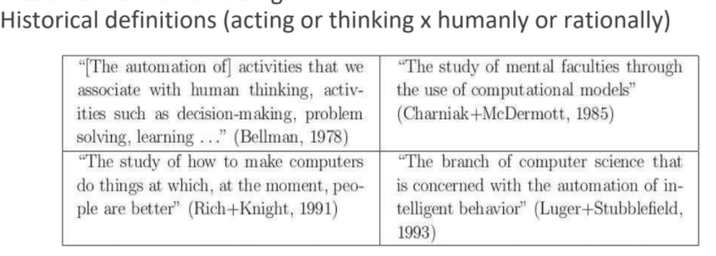

Applications of AI (Any 5)

1. **Optical Character Recognition (OCR):** Scanning typewritten/handwritten documents, finger prints, etc.
2. **Voice Recognition**: Transcribing spoken words into ASCII text.
3. **Medical Diagnosis**: Assisting doctors with their diagnosis by analyzing the reported symptoms and/or medical imaging data such as MRIs or X-rays.
4. **Oil Industry**: To assist in predict PVT properties, Permeability Prediction, and Measure the reservoir Characterization,…etc.
5. **Target Recognition**: Military application which uses video and/or infrared image data to determine if an enemy target is present.
6. **Targeted Marketing**: Finding the set of demographics which have the highest response rate for a particular marketing campaign.
7. **Intelligent Searching**: An internet search engine that provides the most relevant content and banner advertisements based on the users' past behavior.
8. **Fraud Detection**: Detect fraudulent credit card transactions and automatically decline the charge.

**2. Discuss the foundations of AI.**

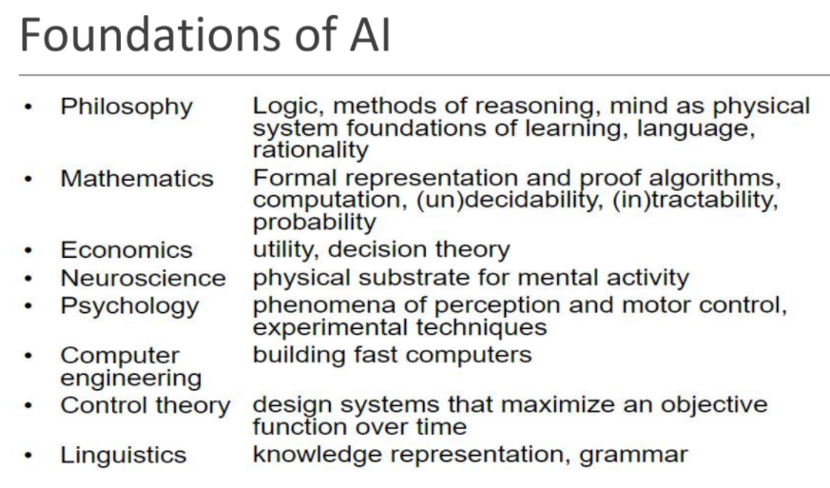

Refer ppts for detailed explanation

**3. Define in your own words the following terms “rationality” and “rational agents”**

**Rationality**

Rationality is nothing but the status of being reasonable, sensible, and having a good sense of judgment.

Rationality is concerned with expected actions and results depending upon what the agent has perceived. Performing actions with the aim of obtaining useful information is an important part of rationality.

What is rational at any given time depends on four things:

■ The performance measure that defines the criterion of success.

■ The agent’s prior knowledge of the environment.

■ The actions that the agent can perform.

■ The agent’s percept sequence to date.

**Rational Agent**

For each possible percept sequence, a *rational agent* should select an action that is expected to maximize its performance measure, given the evidence provided by the percept sequence and whatever built-in knowledge the agent has.

**4. Summarize any four common benefits of Artificial Intelligence Technology. Also list any four most powerful AI companies and briefly discuss their contribution to the world.**

Main advantages of Artificial Intelligence:

1. High Accuracy with less errors
2. High-Speed
3. High reliability
4. Useful for risky areas
5. Digital Assistant
6. Useful as a public utility

AI Companies *(Remember FAANG)*

**Amazon**

Trade giant Amazon has invested in both the consumer-oriented side of AI and in applications for companies and their processes. Alexa, the company’s AI language assistant, integrated into its echo speaker series, is well-known worldwide. However, Amazon Web Services (AWS), a set of machine learning programs and pre-trained AI services for businesses, hasn’t yet done so much. AWS currently has more than 10,000 customers, including Siemens, Netflix, Tinder, NFL, and NASA.

**In**

**Apple**

Apple has been busy acquiring AI start-ups in recent years and sees Artificial Intelligence as a critical part of its future. In December 2018, the company officially appointed John Giannandrea as head of the AI and Machine Learning department after Google poached the Scottish computer scientist. He will oversee the development of products such as Siri and the company’s new Create ML tool, which MacOS and iOS developers can use to create efficient and straightforward training courses for their apps.

**Facebook**

Artificial intelligence will be enormously powerful in the future. So it’s no surprise that Facebook is investing in AI. Facebook’s AI research group, known as FAIR, says it is committed to advancing the field of machine intelligence and developing new technologies to provide people with better ways to communicate. Mark Zuckerberg and Co. worked on a negotiation platform with two AIs called Alice and Bob, among other things, but ended the project after the couple began communicating in their secret language.

**Google**

Perhaps the largest and most important AI company on this list is also the most obvious. Google has acquired AI start-ups as if there were going to be no more soon. Over the past four years, Mountain View has created no fewer than twelve new artificial intelligence companies. The most important purchase was the $400 million deal for DeepMind, the board game playing Go champion. There is also Google’s machine system TensorFlow, which is now free for all, and the ongoing Tensor AI chip project for machine learning on the device. Google’s CEO, Sundar Pichai, has already mentioned that in the long run we are “evolving from a ‘mobile first’ to an ‘AI-first’ world in the computer industry,” and that already says everything you need to know to see where Google sees the future.

**5. With a neat diagram explain agents interact with environment through sensors and actuators.**

An agent is anything that can be viewed as perceiving its environment through sensors and acting upon that environment through actuators

*Human agent*: eyes, ears, and other organs for sensors; hands,legs, mouth, and other body parts for actuators

*Robotic agent*: cameras and infrared range finders for sensors;various motors for actuators

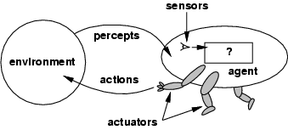

The agent function maps from percept histories to actions:

[**f**: P* 🡪 A]

The agent program runs on the physical architecture to produce function **f**

**agent = architecture + program**

**Architecture** is the machinery that the agent executes on. It is a device with sensors and actuators, for example, a robotic car, a camera, a PC.

**Agent program** is an implementation of an agent function. An agent function is a map from the percept sequence(history of all that an agent has perceived to date) to an action.

**6. Define PEAS as applied to agents. Develop PEAS description of an agent that reports threat of tsunami activity. Determine what type of agent architecture is most appropriate (table lookup, simple Reflex, goal-based, or utility-based). Give a detailed explanation and justification of your choice.**

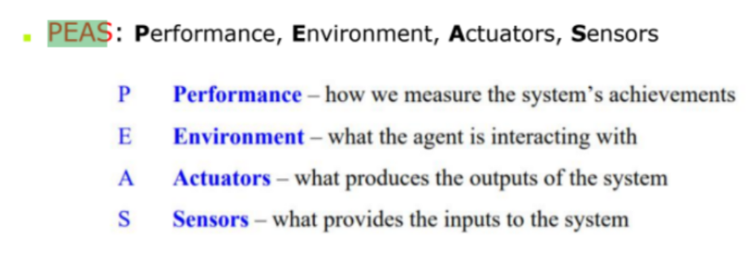

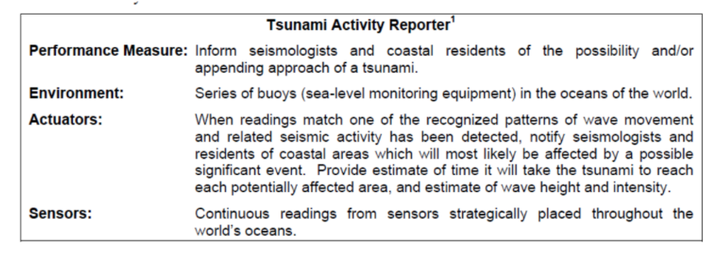The patterns which the agent uses are matched against sets of events that occur over

time.

Therefore, the agent needs to maintain knowledge of the past, and, thus, cannot be either a table lookup or simple reflex agent. If you assume that the patterns do not overlap and are clearly distinguishable from one another, then the agent could be viewed as goal-based. On the other hand, if you assume that the patterns do overlap, and that one must consider such factors as the likelihood of one event occurring over another, then the agent would be viewed as utility-based.

1. **Draw the block diagram of a learning agent and explain its components. State one real time example where the learning agent would correctly fit in.**

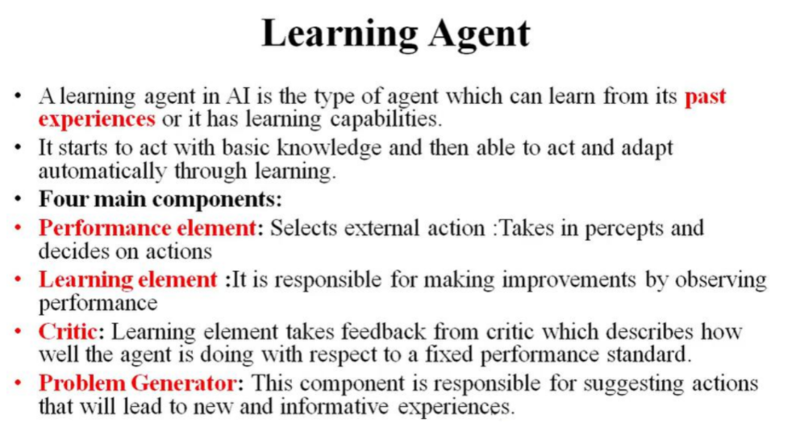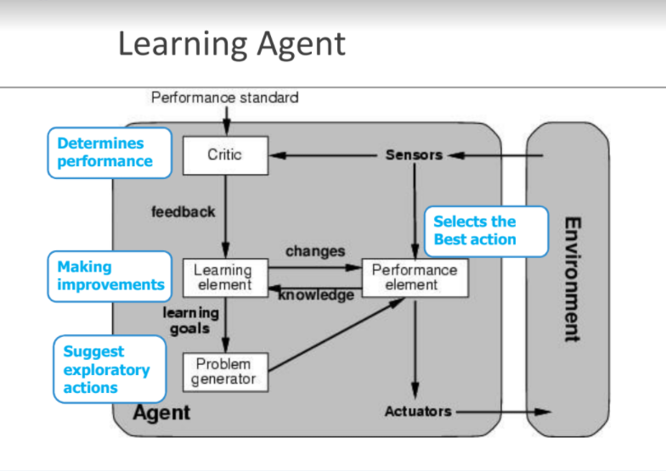

The human is an example of a learning agent. For example, a human can learn to ride a bicycle, even though, at birth, no human possesses this skill.

**8. Discuss briefly the properties of the task environment of agents and types of environments. Give suitable examples and tabular description to support your answers.**

***Properties of Task Environments:***

**Fully observable (vs. partially observable):** An agent's sensors give it access to the complete state of the environment at each point in time. They are Convenient because they need not maintain any internal state to keep track of the world

Eg: Chess with a clock, Image analysis.

**Partially Observable**: because of noise and inaccurate sensors or because parts of the state are simply missing from the sensor data.

Eg: Vacuum agent with only a local dirt sensor

Automated taxi cannot see what the other drivers are thinking

**Deterministic (vs. stochastic):** The next state of the environment is completely determined by the current state and the action executed by the agent, then we say the environment is deterministic; otherwise, it is stochastic.

Eg1: Image-analysis ( deterministic) crossword puzzle.

Eg2: Taxi driving( stochastic) : because one can never predict the behavior of the traffic exactly.

**Episodic (vs. sequential)**: The agent's experience is divided into atomic "episodes" (each episode consists of the agent perceiving and then performing a single action), and the choice of action in each episode depends only on the episode itself.

Eg: Agent that has to spot defective parts of an assembly line bases each decision on the current part, regardless of previous decision.

(chess and taxi driving are sequential)

***Types of Environments***

**Static (vs. dynamic):** The environment is unchanged while an agent is deliberating. (The +--environment is semi-dynamic if the environment itself does not change with the passage of time but the agent's performance score does)

Taxi Driver: Dynamic; Crossword Puzzles: static

**Discrete (vs. continuous):** A limited number of distinct, clearly defined percepts and actions.

A discrete-state environment such as a chess game.

Eg: Taxi driving continuous state and time.

**Single agent (vs. multiagent):** An agent operating by itself in an environment.

Eg: Agent solving a crossword: Simple

Chess Playing: Two –agent environment

Opposite agent…maximizes or minimizes the present agent performance

Taxi –driving environment: cooperative multi agent environment.

**Chess with Chess without Taxi driving**

**a clock a clock**

**Fully observable** Yes Yes No

**Deterministic** Strategic Strategic No

**Episodic**  No No No

**Static**  Semi Yes No

**Discrete** Yes Yes No

**Single agent** No No No

**9. For each of the following agents, develop a PEAS description and list the properties of the task environment:**

**i. Robot soccer player; ii. Satellite image analysis system**

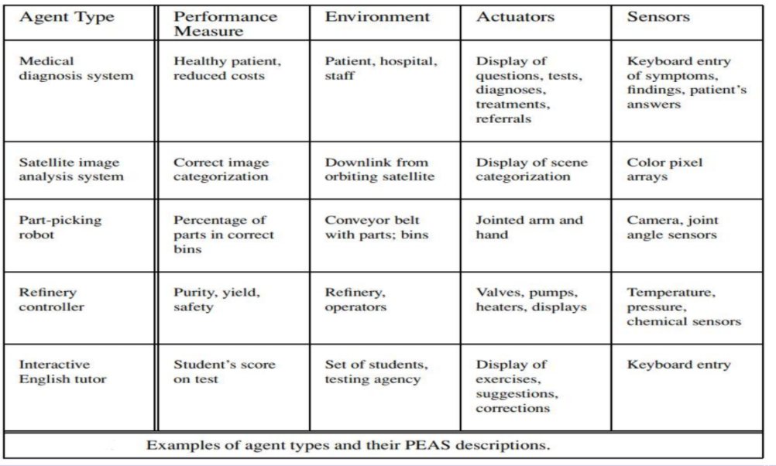

**10. For each of the following assertions, say whether it is true or false and support your answer with examples or counter examples where appropriate.(*HELP*)**

i. An agent that senses only partial information about the state cannot

be perfectly rational.

ii. There exist task environments in which no pure reflex agent can

behave rationally.

iii. There exists a task environment in which every agent is rational.

iv. The input to an agent program is the same as the input to the

agent function.

v. Every agent function is implementable by some program/machine

combination.

vi. Suppose an agent selects its action uniformly at random from the

set of possible actions. There exists a deterministic task

environment in which this agent is rational.

vii. It is possible for a given agent to be perfectly rational in two

distinct task environments.

viii. Every agent is rational in an unobservable environment.

**11. Write the algorithm of the simple problem solving agent. Using the example of the water jug problem explain how formulating the problems as a state space search would be beneficial.**

* Four general steps in problem solving:
  + Goal formulation
    - What are the successful world states
  + Problem formulation
    - What actions and states to consider given the goal
  + Search
    - Determine the possible sequence of actions that lead to the states of known values and then choose the best sequence.
  + Execute
    - Give the solution, perform the actions.

**Pseudocode:**

**function** SIMPLE-PROBLEM-SOLVING-AGENT(*percept*) **return** an action

**static**: *seq*, an action sequence

*state*, some description of the current world state

*goal*, a goal

*problem*, a problem formulation

*state* ← UPDATE-STATE(*state*, *percept*)

**if** *seq* is empty **then**

*goal* ← FORMULATE-GOAL(*state*)

*problem* ← FORMULATE-PROBLEM(*state*,*goal*)

*seq* ← SEARCH(*problem*)

*action* ← FIRST(*seq*)

*seq* ← REST(*seq*)

return *action*

**12. Write the pseudo code of a simple Table Driven Agent. Do chess, taxi driver agent and vacuum cleaner agent behave rational when they are table driven? Justify with reasons.**

Pseudo Code

**function** TABLE-DRIVEN-AGENT(percept) returns an action

**persistent**: percepts, a sequence, initially empty

      table, a table of actions, indexed by percept sequences, initially fully specified

 append percept to the end of percepts

 action ← LOOKUP(percepts, table)

**return** action

Table-driven agent program is invoked for each new percept and returns an action each time. It keeps track of the percept sequence using its own private data structure

**[Do chess, taxi driver agent and vacuum cleaner agent behave rational when they are table driven? ]**

**13. Explain all the agents with a neat diagram.**

* **Simple reflex agent**
* **Model-based reflex agent**
* **Goal based agent**
* **Utility based agent**

**Simple reflex agent**

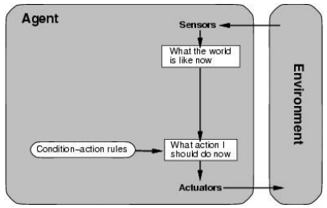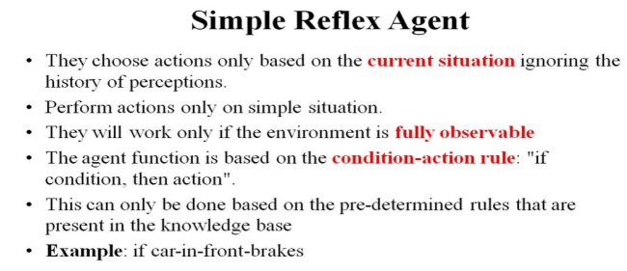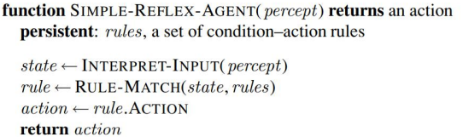

**Model-based reflex agent**

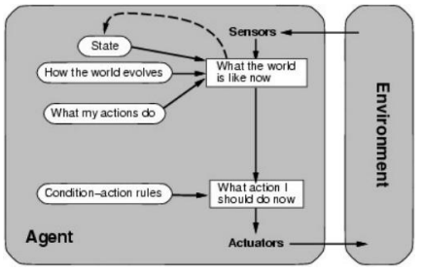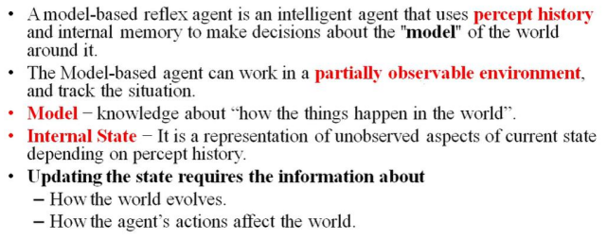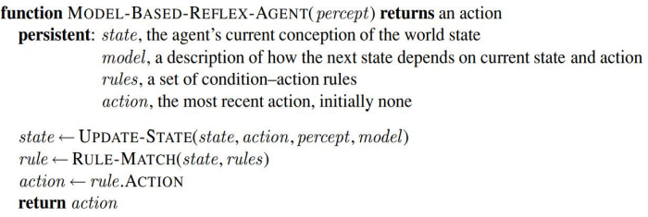

**Goal based agent**

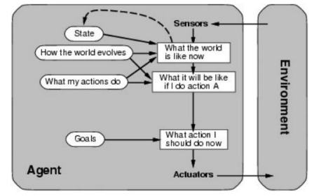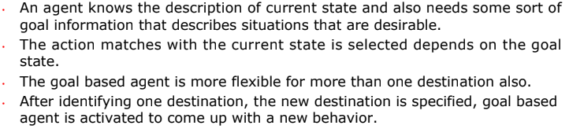

**Utility based agent**

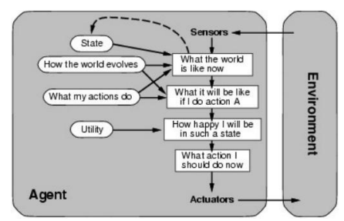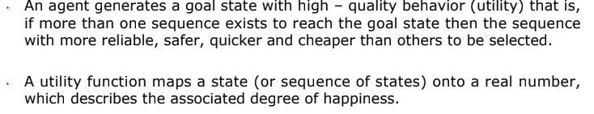

**14 . Give the initial state, goal test, operators, path cost function for the 8 puzzle problem and write the state space diagram.**

**15. Apply problem solving approach to formulate vacuum cleaner agent problem. Justify the solution using a state space tree.**

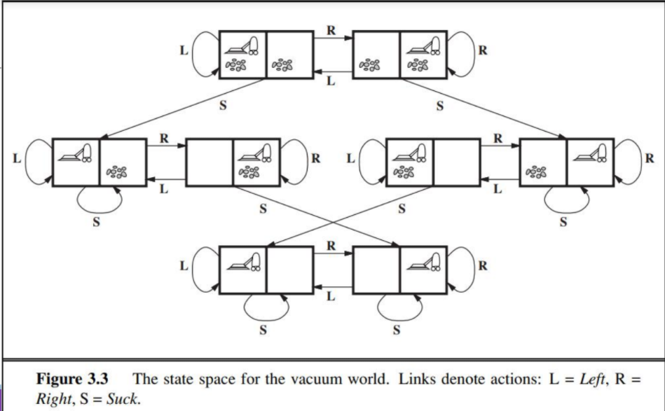

**16.What are the four ways to evaluate an algorithm's performance? Write the algorithm for a general tree search algorithm.**

The evaluation of a search strategy in 4 ways:

**Completeness**:

◦ is the strategy guaranteed to find a solution when there is one?

**Optimality**:

◦ does the strategy find the highest-quality solution when there are several different

solutions?

**Time complexity**:

◦ how long does it take to find a solution?

**Space complexity:**

◦ how much memory is needed to perform the search?

